PROGRAM 3: MISSIONARIES AND CANNIBALS PROBLEM
Aim
To write a Python program to solve the Missionaries and Cannibals Problem.

Objective
To safely move 3 missionaries and 3 cannibals from the left river bank to the right river bank without allowing the cannibals to outnumber the missionaries on either bank.

Algorithm
- Start.
- Initialize 3 missionaries and 3 cannibals on the left bank.
- Move people across the river using a boat that carries at most 2 people.
- After each move, check if missionaries are safe on both banks.
- Repeat valid moves until all people reach the right bank.
- Display all the steps.
- Stop.

Source Code
steps = [
"Left: 3M 3C | Right: 0M 0C",
"2 Cannibals cross",
"Left: 3M 1C | Right: 0M 2C",
"1 Cannibal returns",
"Left: 3M 2C | Right: 0M 1C",
"2 Missionaries cross",
"Left: 1M 2C | Right: 2M 1C",
"...",
"Goal Reached!"
]

for step in steps:
print(step)

Flowchart
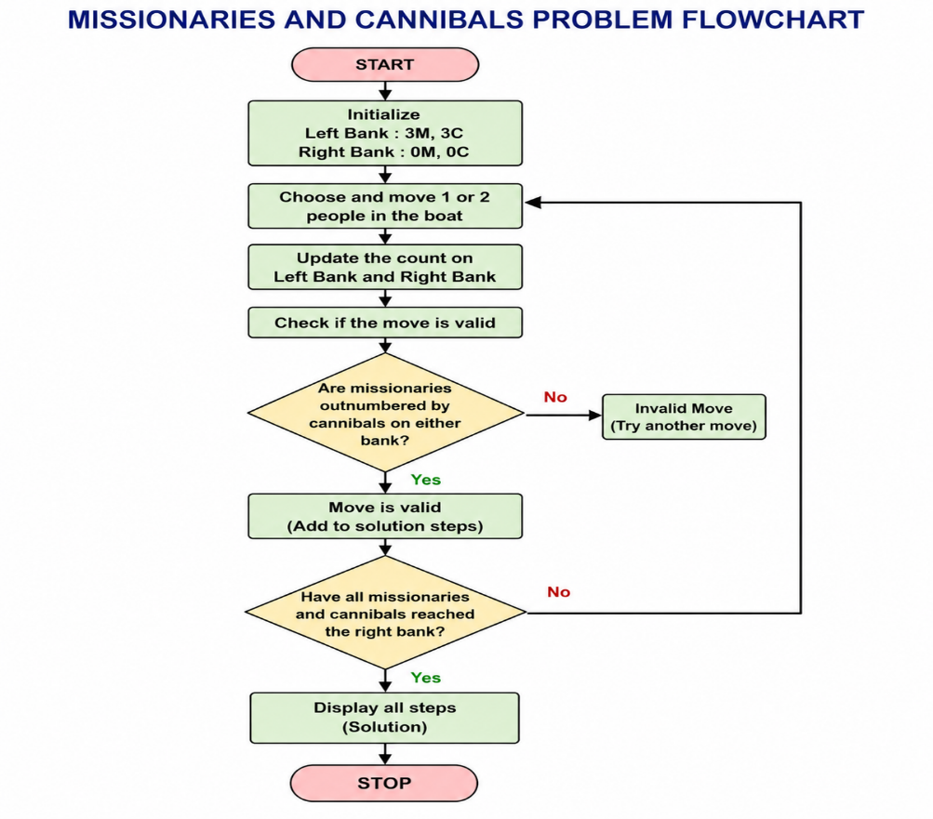

Sample Output
Left: 3M 3C | Right: 0M 0C
2 Cannibals cross
Left: 3M 1C | Right: 0M 2C
1 Cannibal returns
Left: 3M 2C | Right: 0M 1C
2 Missionaries cross
...
Goal Reached!
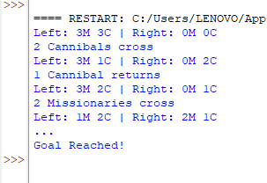
Result
Thus, the Python program to solve the Missionaries and Cannibals Problem was executed successfully.

